Freidin Brown P.A. Attorneys Selected to Super Lawyers 2022
June 30, 2022- Freidin Brown, P.A. is proud to announce that five attorneys have been named as Florida Super Lawyers and Rising Star. The “Super Lawyer” distinction is given to less than five percent of attorneys in each state. The patented selection process includes independent research, review of their verdicts/settlements, peer nominations, and peer evaluations.
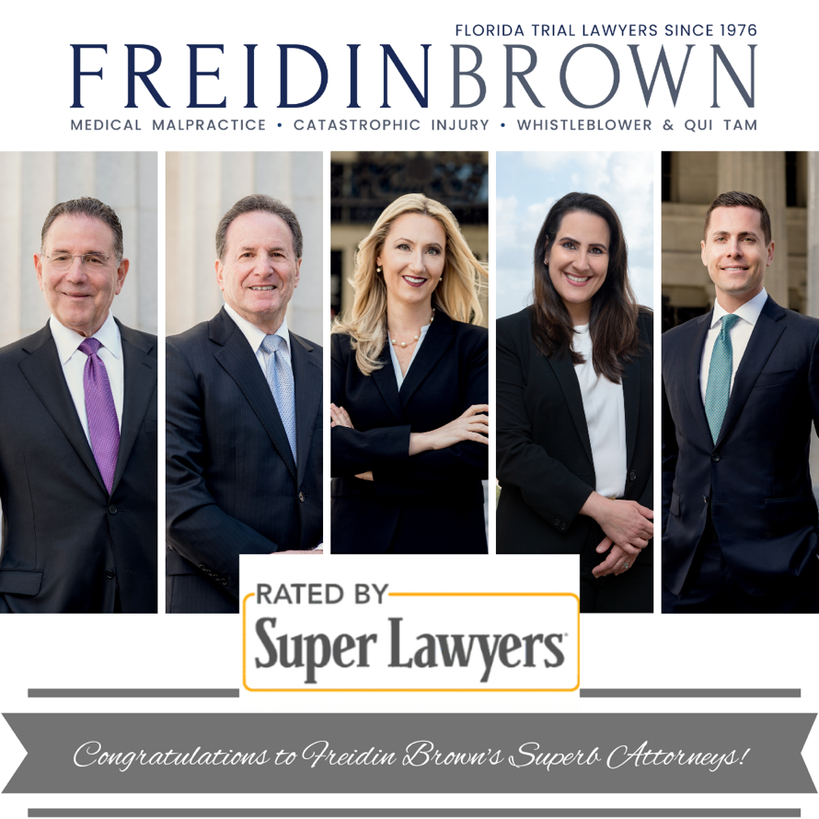
Freidin Brown, P.A. received recognition in Personal Injury on the plaintiff’s side. It is an honor that is reserved for attorneys who exhibit excellence in practice.
For the 5th consecutive year, Jonathan Freidin has been selected as a “Rising Star”. While up to five percent of the lawyers in the state are named to Super Lawyers, no more than 2.5 percent are named to the Rising Stars list.

2022 Super Lawyers:
Philip Freidin- Top Rated Personal Injury General Plaintiff Attorney
Joel H Brown- Top Rated Personal Injury General Plaintiff Attorney
Lara Dabdoub – Top Rated Personal Injury Medical Malpractice Plaintiff Attorney
Whitney Untiedt- Top Rated Personal Injury General Plaintiff Attorney

2022 Rising Star:
Jonathan Freidin - Top Rated Personal Injury General Plaintiff Attorney

